

**Proforma for nomination - Program Representative**

**(Kindly go through the eligibility criteria before filling the form)**

Submit the form, in **soft copy** with adequate proofs, to your respective school Dean/HoD on or before **26th August 2020**

**Eligibility Criteria for Program Representatives**

* Must have expressed interest, participated, and performed remarkably in co-/extra-curricular activities in previous years.
* Shall have strong Leadership Qualities.
* Students having more than **7.5 CGPA** are eligible. For first years VITEEE ranking or their previous leadership proofs can be considered instead of CGPA.
* Students should not have any **standing arrears**.
* Students should not have any **disciplinary proceedings** against them.

**Purpose** of **Program Representatives**

* Represent the students’ issues or concerns of their programme.
* Students are given an opportunity to develop leadership qualities by organizing and carrying out various activities
* To plan events that contributes to the University and community welfare.
* To enhance communication between students, management, faculty and parents
* To promote an environment conducive to educational and personal development
* To promote friendship and respect among students
* To support the management and staff in the development of the University
* To represent the views of the students on matters of general concern

**Nomination for Program Representative**

1. NAME : Mohit Madhukar More
2. REG. No. : 19MIA1005
3. PROGRAM : MIA
4. BRANCH : CSE
5. SCHOOL : SCOPE
6. Email ID :mohitmadhukar.more19@vitstudent.ac.in
7. Mobile No. : 9011485453
8. Hosteller / Dayscholar : Hosteller
9. ACADEMIC PERFORMANCE :

|  |  |  |  |
| --- | --- | --- | --- |
| SEMESTER | GPA | SEMESTER | GPA |
| I | 9.38 | VI |  |
| II | 9.77 | VII |  |
| III | 9.72 | VIII |  |
| IV | 9.2 | IX |  |
| V |  | X |  |
| CGPA Total | | 9.52 | |

If first year, furnish your VITEEE ranking:

% in XII std. :

1. ARE YOU REGISTERED WITH VIT PAT (for III and IV year students): NO
2. Member of Students’ Clubs/Chapters/Professional Societies (Duration / Year)

a) VITEach (Winter Semester - 2020)

b) Voice IT(Winter Semester – 2021)

1. Participation in Co & Extra-Curricular Activities & Prizes Won (Duration / Year)
2. Administrative Achievement - Program representatives, Students Council, Class Representatives, President of Students Chapters & Clubs ( Please Mention the Year & Duration)

a)

b)

c)

1. Academic Achievements (Endowment Awards, Scholarships, Papers Presented in National & International level)
2. Sports Achievements (Duration / Year)
   1. Intramurals
   2. Outside VIT (TIES Etc.)

:

1. Details of Competitive Examination (for III and IV year students):

|  |  |  |  |  |
| --- | --- | --- | --- | --- |
| ***S.No.*** | ***Name of the Exam*** | ***Score*** | ***Year of***  ***appearance*** | ***Remarks*** |
|  | CAT *(Common Aptitude Test)* |  |  |  |
|  | MAT |  |  |  |
|  | GATE |  |  |  |
|  | G-MAT |  |  |  |
|  | GRE |  |  |  |
|  | IELTS *(International English Language Testing System)* |  |  |  |
|  | TOEFL |  |  |  |
|  | BEC |  |  |  |
|  | NET, SLET, IAS, Defence Entrance,  Other services, Any other (specify) |  |  |  |

1. PROFICIENCY IN LANGUAGE (Please underline Mother Tongue)

|  |  |  |  |  |
| --- | --- | --- | --- | --- |
| ***S.No.*** | ***Language*** | ***Speak*** | ***Read*** | ***Write*** |
|  | English | Yes | Yes | Yes |
|  | Hindi | Yes | Yes | Yes |
|  | Marathi | Yes | Yes | Yes |
|  |  |  |  |  |

1. DETAILS OF ANY SPECIAL ACHIEVEMENTS (Enclose extra sheet, if required)
2. Youth India Foundation : I joined Youth India E-School and worked with them in Summer Holidays (2020).This is my Letter of Joining.

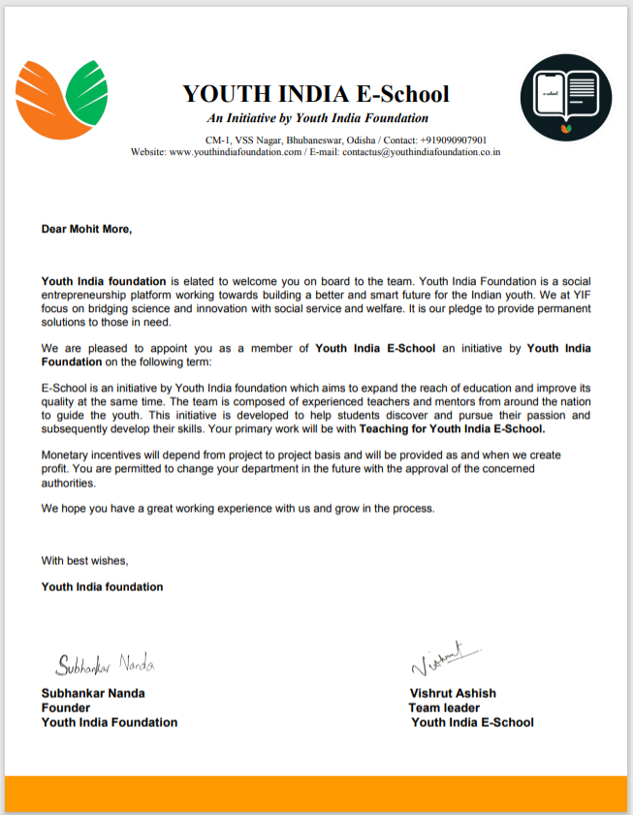

1. Jazz Hands Foundation :- I worked with Jazz Hands in the Summer Holidays(2020). This is my letter of Nomination.

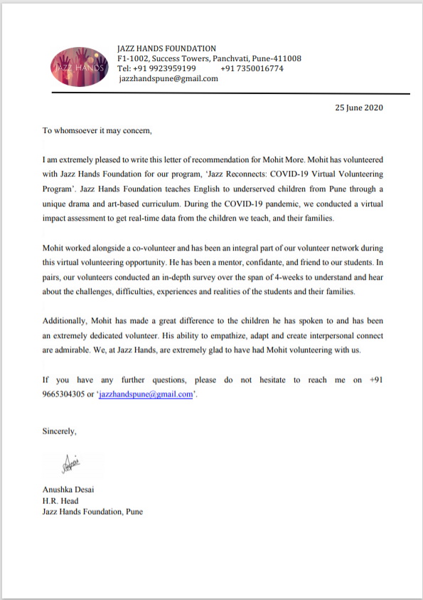

1. ANY OTHER RELEVANT DETAILS: (Enclose extra sheet, if required)

DECLARATION:

I certify that the information furnished above factually correct and subject to verification. All the details given are true to best of my knowledge.

*MOHIT MADHUKAR MORE*

(Type the Name in CAPITAL LETTERS)

**Enclosures:**

1. Academic history - CGPA proof with no standing arrears - attested by proctor
2. No disciplinary records – Statement from proctor
3. Club membership, positions held as office bearers and events conducted / participated (external & internal) – proof attested by Faculty in-charge of the club
4. Proofs for
   1. any peer mentoring / counseling
   2. notified any student issues/concerns to the higher officials
   3. any other information that adds value

**All the details are mandatory and any incomplete/insufficient or fraudulent data proofs may lead to rejection of the application.**